Tab 1

DASH Azure Red Hat OpenShift

Input Guide
This section outlines the input parameters required for provisioning an Azure Red Hat OpenShift (ARO) cluster using the DASH Portal. Each parameter includes a description, available options, guidance for selecting appropriate values, and notes on any valid combinations where applicable

Input Parameter | Description | Values Provided | Value Guidance | Valid Combinations
region | Azure region where the ARO cluster will be deployed | e.g., East US, Central US, West US 2, Central India, UK South, Canada Central, East Asia, South Central US | Choose a region where ARO is supported and close to users or dependent services | Must be an ARO-supported region
cluster_name | Name of the Azure Red Hat OpenShift cluster | Any alphanumeric string with dashes | Use a clear, unique name to identify your OpenShift cluster | Must be globally unique in your subscription
domain_name | DNS domain name for your ARO cluster | e.g., dash | Ensure the domain is routable and not in conflict with existing services | Should correspond to a DNS zone you control
disk_size_gb | Size (in GB) of the OS disk for each node in the cluster | Numeric, preferred: 128 | Choose based on workload and container image needs | Min disk size depends on node size
node_count | Number of worker nodes in the OpenShift cluster | Numeric, preferred: 3 | Minimum 3 for high availability; scale based on app requirements | Must meet ARO minimum sizing (usually ≥3)
owner | The team or individual responsible for provisioning, managing, and maintaining the resource. | Specify the team name or individual responsible for maintaining the cluster. | Provide correct team/individual name. | N/A
application | Associated service or application name for the resource. | Enter the associated service name linked to the cluster. | Provide a service name linked to the cluster. | N/A
project | Project or initiative name linked to the resource. | Indicate the project or initiative name related to the resource. | Provide the project name related to the resource. | N/A
deployment | The target environment (e.g., development, testing, prod) where the resource will be provisioned. | Define the deployment environment name (e.g., dev, test, prod) | Choose the environment where the cluster has to be deployed. | N/A
Services expire after 30 days. Create this service now, or schedule for a later date? | Cluster will be deleted 30 days after creation, or it can be scheduled to be created at a later date. | Create Now (or)  Schedule for Later | Choose based on cluster requirements. | N/A

Sample Input Selection:
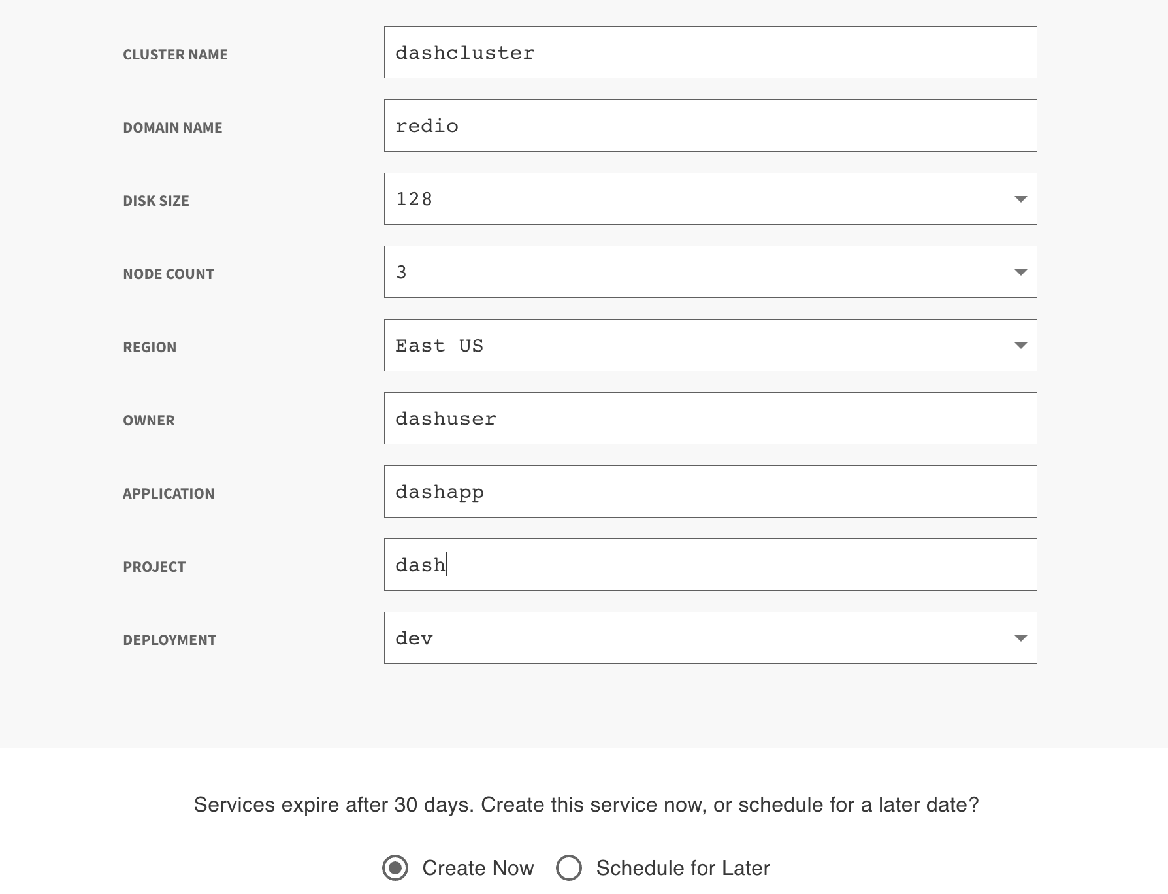

Output Guide:
After provisioning the ARO cluster, the following output values are available. These are essential for accessing the OpenShift console, authenticating to the cluster, and managing workloads.
Output | Description | Example / Notes
console_url | OpenShift Web Console URL | Web UI to manage cluster resources (e.g., https://console-openshift-console.apps.aro.example.com)
cluster_credentials | Command to retrieve cluster admin credentials | az aro list-credentials --name <cluster_name> --resource-group <resource_group>
cluster_access | Commands to authenticate and connect to the cluster | az login  az account set --subscription <subscription_id>  az aro list-credentials --name <cluster_name> --resource-group <resource_group>
kubeadminusername | Cluster admin username | Default is 'kubeadmin'
kubeadminPassword | Cluster admin password | Extracted from remote file data; used for console login

What You Can Do with These Outputs
The outputs provided after provisioning your Azure Red Hat OpenShift (ARO) cluster enable you to securely access and manage your cluster through both the OpenShift Web Console and CLI tools.
Access the OpenShift Web Console
Open a browser and go to the Console URL from the output:
https://console-openshift-console.apps.<your-domain>
Log in using the kubeadmin username and password:
  - Username: kubeadmin
  - Password: from the kubeadminPassword output

